General Physics A (II) – Spring Semester 2019 Homework Set 3

**B07902074張媄姞**

1.

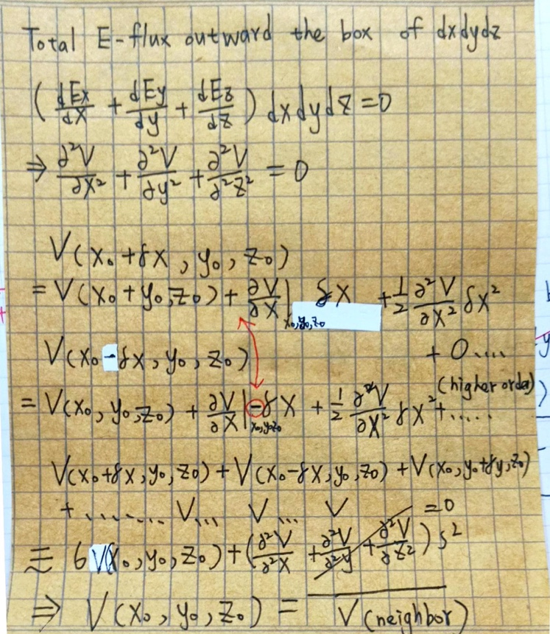

2.

When we set V1,V2,V3,V4 as following:

V[(0, 0)] = 5V V[(0, 30)] = -10V V[(30, 30)] = -15V V[(30, 0)] = 0V

The right profile represents the potential distribution within the hollow region.

The left profile represents the field distribution within the hollow region.

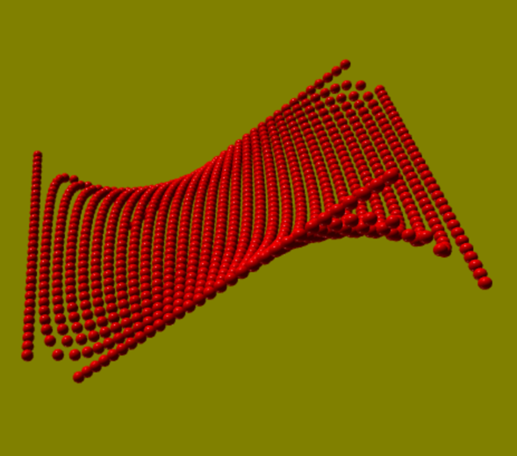 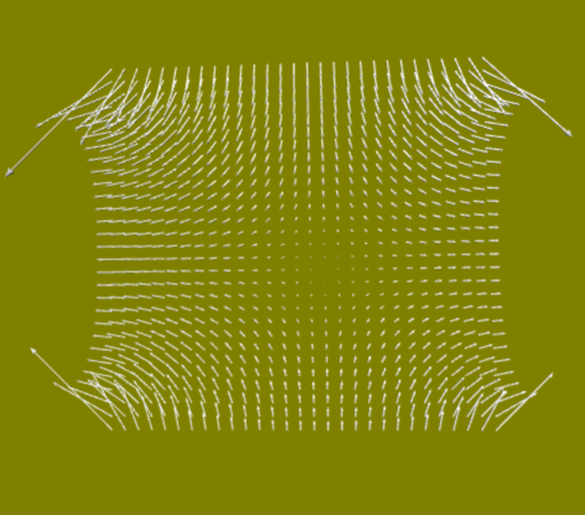

Code explanation:

